Wildfire Proximity and Housing Prices in California
Lauren Bolte
University of California, San Diego
GPEC 443: GIS & Spatial Data Analysis
Professor McCord
December 12, 2025

California natives are very familiar with the threat that wildfires pose to both their rural, suburban, and even urban landscapes. With many populated regions lining up directly with fire-prone ecosystems, the modern environment in this state is the perfect storm for destructive, fire-related disasters. Wildfires that bleed into populated areas and destroy housing structures have become a growing topic of concern as fires further become commonplace with climate changes. Although destruction of structures is not a new phenomenon within California wildfire history, the recent Palisades fire in the beginning of 2025 has brought the topic to the center of attention. The economy can be impacted by natural disasters in a number of different ways. The damage caused by fires affects local, regional, and statewide communities and disrupts normal social community behavior. One component of the economy that can give us insight into the change wildfires initiate is the housing market. Understanding how the burn acreage and distance between homes and the fire perimeter changes housing prices is key to informing disaster relief policy. Market behavior can also be used by individual homeowners to more accurately predict their home’s value and make decisions on how to approach the structure damage. By looking at patterns in the housing market in relation to major historical fire events, inferences can be made as to how prices will react to both recent and future fires.
Some of the most destructive fires in California history have taken place after the turn of the century, and utilizing data from these events provide a more accurate inferential foundation than fires further in the past. The events and time periods that are included in this analysis include the 2003 Cedar Fire in San Diego County, the 2017 Tubbs fire in Napa and Sonoma Counties, and the 2018 Camp Fire in Butte County. Temporal visualizations of the housing market surrounding these fire perimeters can give us information on how much distance may or may not have an impact on change outside of general inflation. Statistical analysis through linear regression modeling provides a quantitative reference point for how strong the relationship between price and distance is. The combination of visual and quantitative methods offers a comprehensive, easy to read summary of this relationship.

Methods
This analysis was conducted using extensive data on fire location and extents, median housing prices over time, and ZIP code boundaries (California Department of Technology, n.d.). Historical fire perimeters come from the California Department of Forestry and Fire Protection’s Fire and Resource Assessment Program (FRAP). The dataset receives contributions from a number of different GIS resources such as the National Parks Service and the Bureau of Land Management (California Department of Forestry and Fire Protection, n.d.). Housing data used to determine a relationship between median price and distance from fire perimeters comes from Zillow’s Housing Data repository. The Zillow Home Value Index (ZHVI) is a “measure of the typical home value and market changes across a given region and housing type” that reflects home values between the 35th and 65th percentiles (Zillow Research, n.d.). Data was filtered to only include single family homes by a month time series and organized by California ZIP code. Using only single-family homes to conduct this analysis allows for more accurate predictions for the aftermath of the 2025 Palisades fire, as most of the destroyed structures were included in this category (CoStar, 2025). This filter also offers a simpler reflection of the housing market and still provides a large dataset for a comprehensive analysis. ZIP Code boundaries are used to properly visualize spatial changes in Zillow housing prices. The combination of the data sources allows us to observe statistically significant patterns in market data. All aspects of the data and spatial visualizations are projected in NAD83/California Albers for the most accurate representation of California’s geography.

Analysis
The initial test to determine if the Zillow housing data and distance to fire perimeters had a statistically significant relationship was a multiple fixed-effects model. Since time has a strong impact on changes in housing prices due economic inflation, this type of model allows for confounding variables to be held constant to observe effects between other variables in the data. Before a regression could be performed, the housing data had to be cleaned and organized by distance to fire perimeters. The median price variable was transformed to log(price) to control for variance issues as a result of highly skewed data. Housing price data tends to be skewed due to strong outliers in the distribution. Using log also creates more easily interpretable coefficients in the model output. Distance was calculated as a series of mutually exclusive “bands” that would define each median price observation. Distances included 0 to 5, 5-10, 10-20, and >20 km from a fire perimeter. ZIP code geographic locations were also summarized to centroids to determine if there is a broader-scale effect, rather than variability within ZIP codes. After this data preparation for regression, each observation row contained a ZIP code, population, median price, post office name, date in year-month format, and distance band category. The OLS model input can be seen below. I include a year-month fixed effects by adding a factor variable YM to control for price trends over time:

dist_month_model <- lm(log(price) ~ dist_band + YM, data = zip_prices)

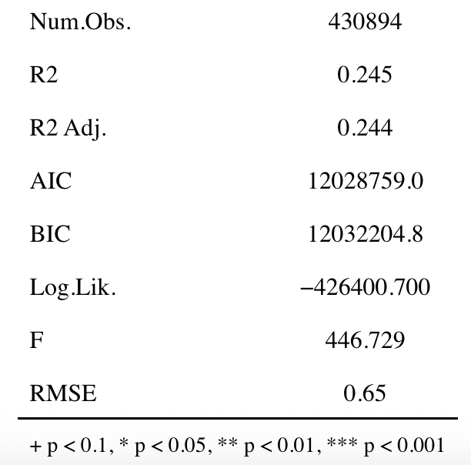
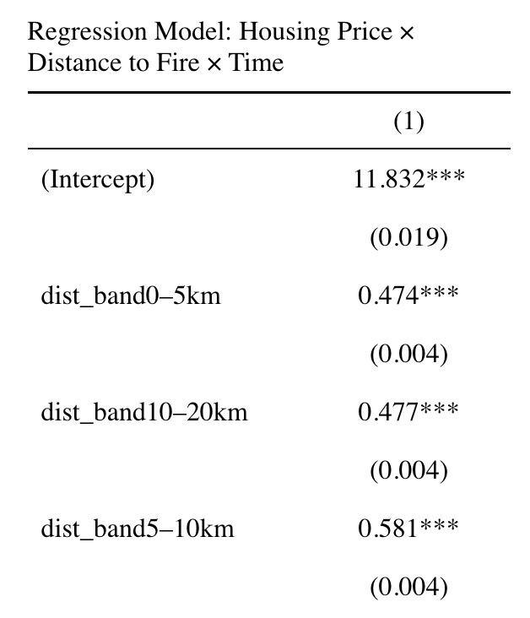
It is important to note that this model does not consider interaction effects between predictor variables. We are still able to control for time and determine a relationship between distance and median price. In the model output, the intercept represents the baseline median house price if distance is >20km from a fire perimeter (our reference distance band) in 2000-01 and the remaining distance bands are listed below. The non-overlapping nature of the data organization ensures avoidance of collinearity, reduces model complexity, and allows for proper comparison of spatial gradients. Each year-month time stamp is also included in the model output beginning at 2000-01, and they are statistically significant after the month 2000-08 (full model output can be viewed here). The R-squared value means that roughly 24% of variance is explained by the model. This is not a strong R-squared value, but we are still able to interpret the coefficients due to their statistical significance. A major issue with the model output that raises concern is the non-monotonic quality of the distance coefficients. Common sense tells us that houses closer to fire perimeters would cost less than houses further away due to less disaster risk. The fixed-effects model suggests that a distance between 5 and 10 km from a fire perimeter would cause the greatest jump in median house price, with the 0-5km bands and 10-20km bands being highly similar in rate of change. This unusual output can be due to several different characteristics of the data. Variance in population between ZIP codes and a lack of geographic controls are two potential explanations.
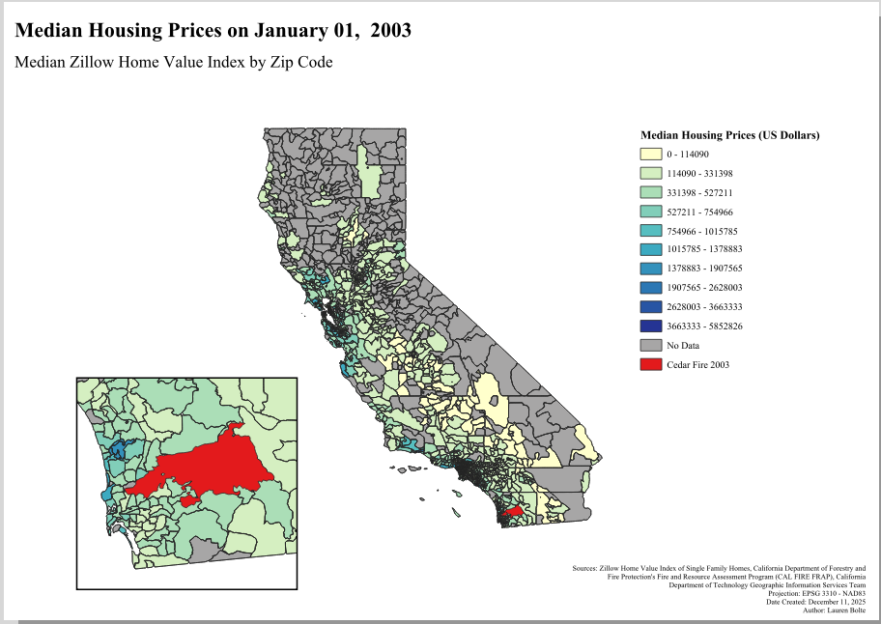
To further understand spatial relationships in the housing data and investigate the unusual regression model output, the results were mapped onto a map of California split up by ZIP code boundaries. The number of historical wildfires after the year 2000 is high, so four major events were chosen for analysis. Median housing price around each fire is shown over a three-year period around the initial alarm date. Major fires were chosen based on acreage burned and proximity to urban regions. Visualizations of the recent Palisades fire are included with only two time stamps since it took place in 2025. We use the other three fire events to make inferences on how the Palisades fire might impact surrounding housing prices in the future.
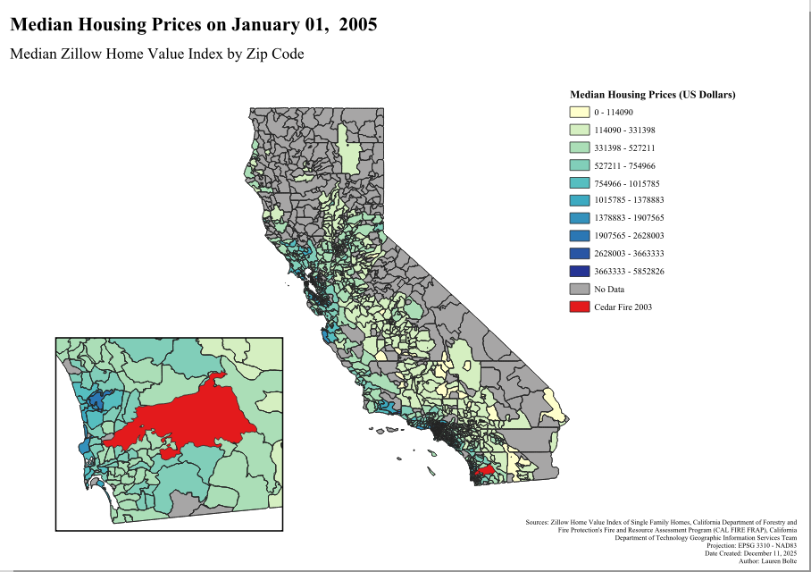
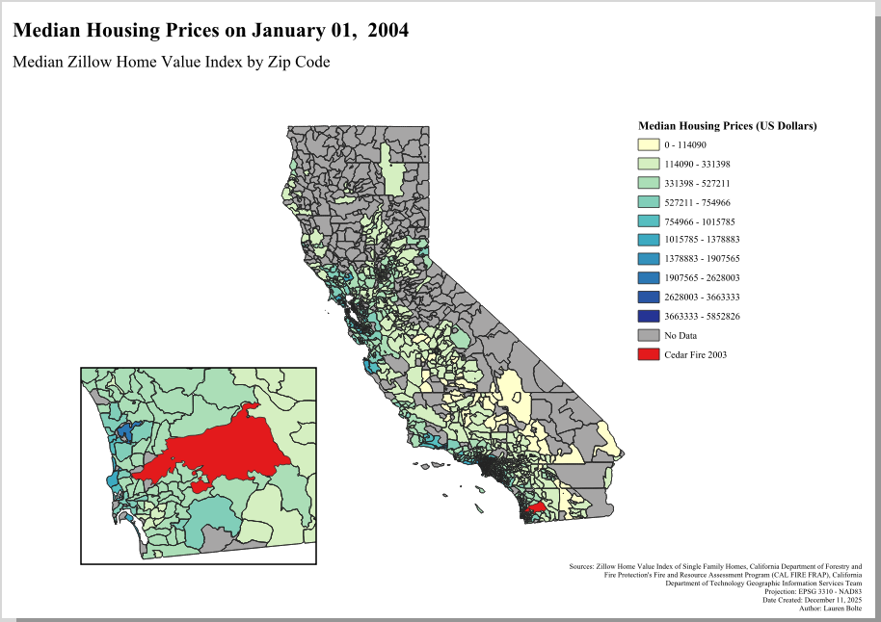
The 2003 Cedar Fire in San Diego County was the largest wildfire in California history at the time of its containment, burning over 280,000 acres and destroying 2,820 buildings (City of San Diego Fire-Rescue Department, n.d.). Over time, we can see that housing prices around the fire rose overall but not dramatically. The area most impacted by the fire includes little rural area and communities with mid to high housing prices. With the >20km distance band falling within more rural areas as it moves away from metropolitan San Diego, prices lower. This follows the model’s seemingly unusual pattern and offers insight into where highly impactful wildfires take place. Desirable and expensive communities often lie near wildfire-prone areas. Analysis of the other major historical fires can offer a similar result and further explanation of the model output.
The 2017 Tubbs fire largely impacted the Napa and Sonoma counties north of the San Francisco area. Another economically advantaged area, this fire affected the community similarly to the Cedar fire of San Diego. More than 5000 structures were destroyed, with half of them being homes in Santa Rosa (Wikipedia contributors, n.d.). We see little variance in the median housing prices over time. This suggests that they remained high due to being in a fire-prone yet desirable area.
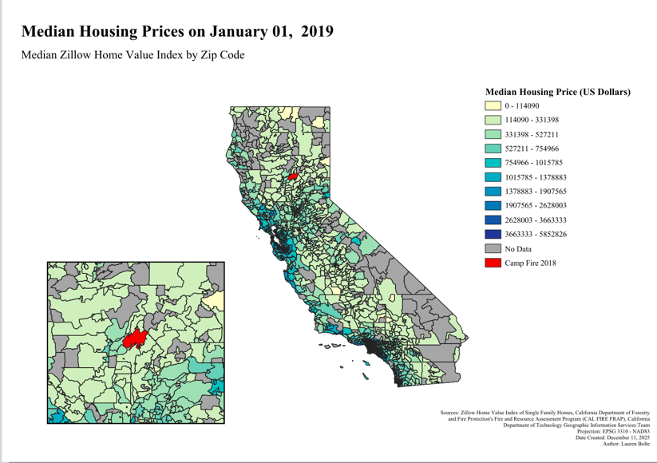
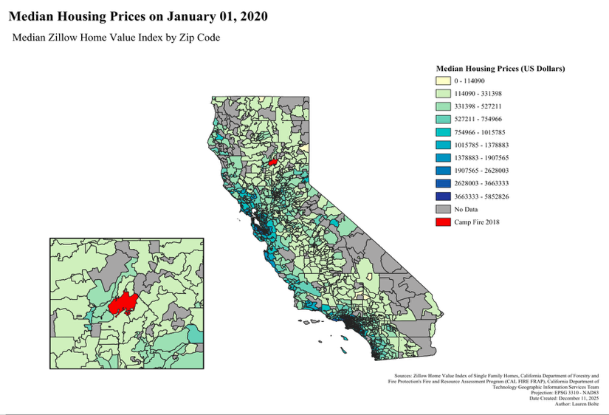
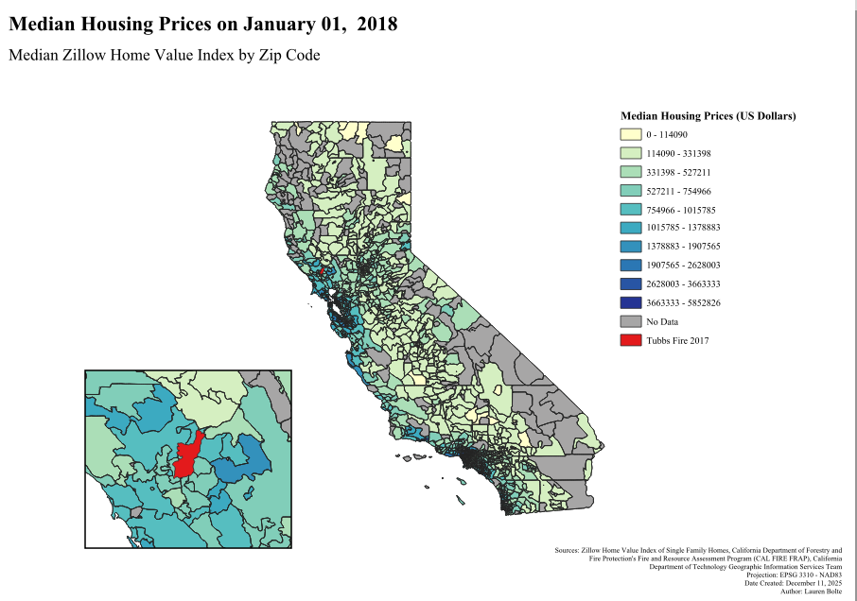
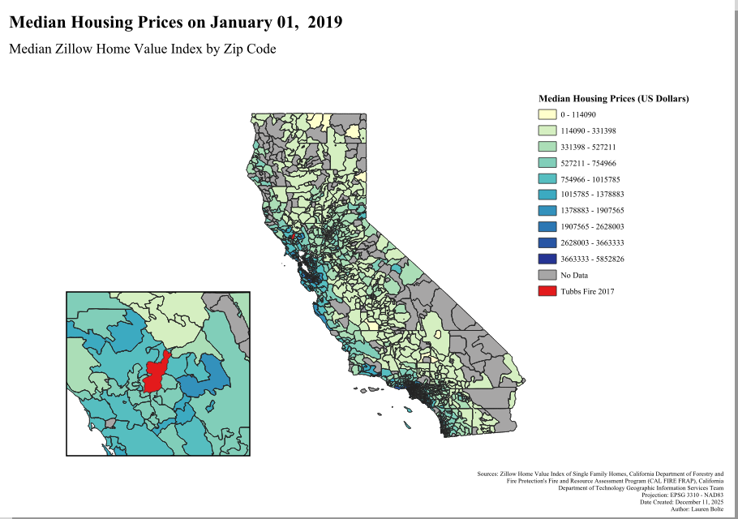
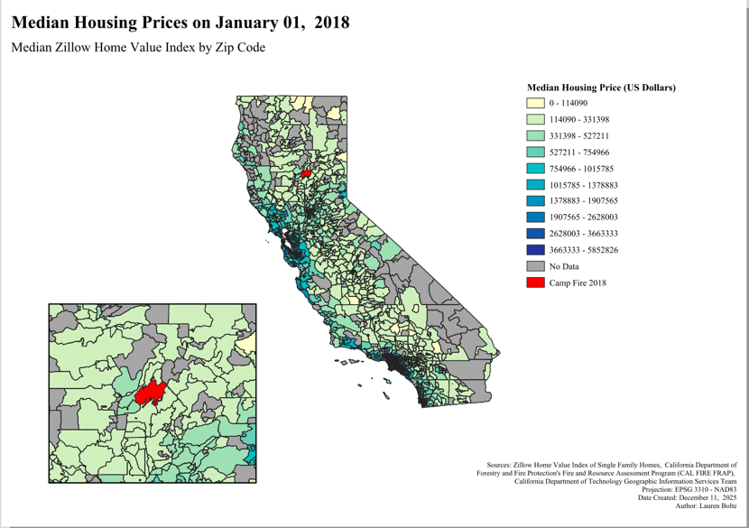
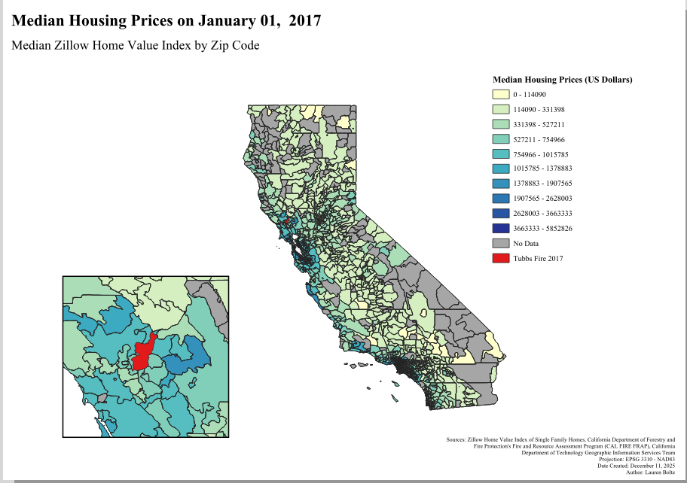
The maps below show median housing prices from 2017-01 to 2019-01 surrounding the Tubbs Fire (left) and prices from 2018-01 to 2020-01 surrounding the Camp Fire (right). Measures were taken from the same dataset as the San Diego Cedar Fire and recent Palisades Fire in Los Angeles.
The 2018 Camp Fire in Butte County offers a slight variance in comparison between these major fire disasters. The fire was just as destructive as the previously mentioned events with around 10,000 single family homes destroyed, but it differs in the geographic location and economic environment (Wikipedia contributors, n.d.). Butte county has a high population but is much more rural and agriculturally focused than the other areas we are analyzing. The visualization of changes in Butte’s median housing prices over time shows a representation of the patterns we would expect after a major wildfire. Prices generally remain the same without any major jumps or decreases but do increase slightly further away from the fire perimeters. This supports the conclusion that housing prices are less impacted by fire damage in affluent areas.
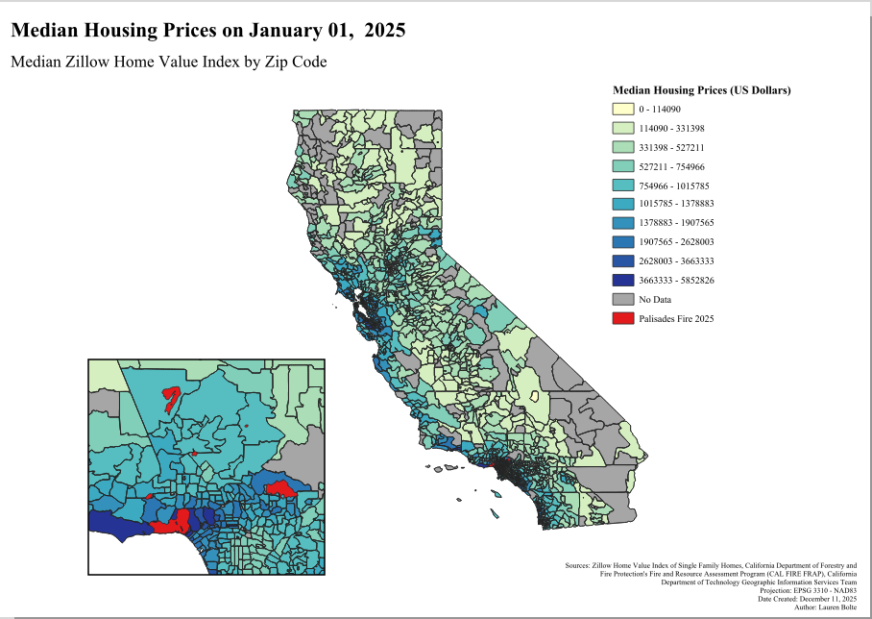
The Palisades Fire in January of 2025 is also one of the most destructive wildfires in California history, and it presents a unique issue due to the high housing prices in the area. The Pacific Palisades is a largely suburban community that is adjacent to Los Angeles proper, and it lines up directly with a fire-prone landscape that makes up much of the Southern California coastline. Approximately 24,000 acres were burned in the fire and almost 7,000 structures were destroyed (California Department of Forestry and Fire Protection, 2025).

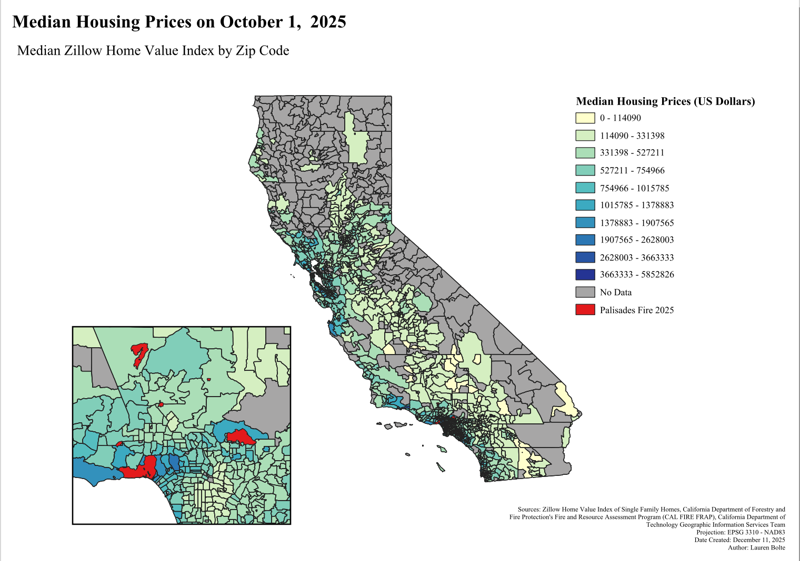
The visualization of the median housing prices in the Pacific Palisades and surrounding areas shows that prices dipped dramatically over the course of 2025. Despite this community being one of the most affluent in the state, these results do not follow the patterns that the similar Cedar and Camp fires provide. However, something to consider with this analysis is that less time as passed since the Palisades Fire was extinguished. Land surrounding the fire perimeters are still under construction and have experienced extensive burn damage. There is insufficient time for recovery patterns to emerge. We can anticipate prices to jump back up by the year 2027 if the market will follow the patterns of historical fire events with similar economic characteristics.

Discussion
Overall, this analysis shows that the relationship between wildfire perimeters and housing prices is driven far more by California’s underlying geography than by the direct effects of fire. Although the fixed-effects regression produced a counterintuitive pattern in which homes closer to fire perimeters appeared more expensive, the spatial visualizations reveal why: large wildfires frequently occur along the edges of high-value suburban communities where housing demand meets highly flammable terrain. In this context, the positive distance-band coefficients reflect where fires tend to occur rather than a causal premium for proximity to fire. This interpretation aligns with the mapped patterns surrounding the Cedar, Tubbs, Camp, and Palisades fires, all of which affected communities that were already relatively expensive prior to burning. Looking ahead to the aftermath of the 2025 Palisades Fire, these results suggest that future changes in median housing prices will be shaped more by broader economic conditions in these “suburban edge” communities than by distance from fire perimeters alone. Finally, limitations such as reliance on ZIP-code centroids, varying population densities, and limited geographic controls highlight the need for finer-scale spatial and econometric approaches to fully understand how wildfire destruction interacts with local housing markets.

References
California Department of Forestry and Fire Protection. (2025). Palisades Fire. https://www.fire.ca.gov/incidents/2025/1/7/palisades-fire
California Department of Forestry and Fire Protection. (n.d.). California fire perimeters (all). https://catalog.data.gov/dataset/california-fire-perimeters-all-5b4ee
California Department of Technology. (n.d.). CA ZIP code boundaries. https://data.ca.gov/dataset/ca-zip-code-boundaries
City of San Diego Fire-Rescue Department. (n.d.). 2003 Cedar Fire. https://www.sandiego.gov/fire/about/major-fires-incidents/2003-cedar-fire
CoStar. (2025). New analysis of L.A. fires reveals property damages top $30 billion. https://www.costar.com/article/1384517962/new-analysis-of-la-fires-reveals-property-damages-top-30-billion
Wikipedia contributors. (n.d.). Camp Fire (2018). https://en.wikipedia.org/wiki/Camp_Fire_(2018)
Wikipedia contributors. (n.d.). Tubbs Fire. https://en.wikipedia.org/wiki/Tubbs_Fire
Zillow Research. (n.d.). Zillow Home Value Index (ZHVI) data. https://www.zillow.com/research/data/

